**Name:____________________ ID: _________________ Mock Exam I**

**Question 1 Fill in the blanks and prove:**

(a) a + (a + d) + (a + 2d) + … + (a + (n-1)d) = __________________

(b) 1/2 + 1/4 + 1/8 + … = ______________

(c) a + ax + ax2 + … +ax(n -1) = _______________

**Question 2 Order these functions in the increasing order of complexity. No need to prove.**

log (n1/2), 2n, n1/3 log n, n1/4 log n, nlog(n), n1/3, log (n/2), (4/3)n

**Question 3**

1. If an array has 100 integers, what is the expected number of inversions?
2. Show Merge sort is not inversion bound.
3. What is meant by a stable sorting algorithm? Is Merge sort stable? Justify your answer.
4. A list all permutations on 4 items. Please use letters a, b, c, and d. For example adbc is one permutation.
5. How many ways you can choose 3 items out of 7?
6. What is $\left({n \atop k}\right)$?
7. What is $\left({n \atop 2}\right)$?
8. Expand (x + y)5

**Question 4** Illustrate merge sort on 5, 10, 7, 2, 4, 8, 1.

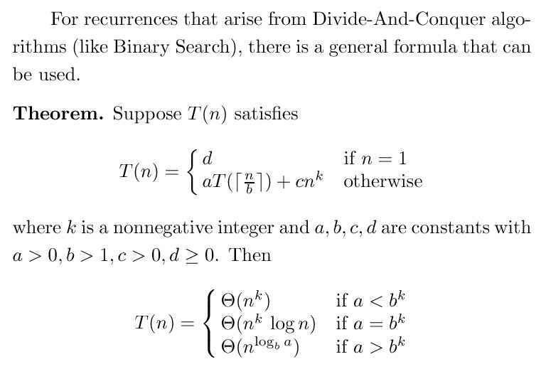

**Question 5**

Dr. MT was designing an algorithm. He found that he can solve the problem by DAC (Divide And Conquer). He has the following two options:

Algorithm A: Divide the problem into 7 sub problems each of size n/3. Further there is only an O(1) cost in combining the solutions of those 7 sub-problems to obtain the solution of the problem.

Algorithm B: Divide the problem into 4 sub problems each of size n/4. Further, there is an O(n) cost in combining the solutions of those 4 sub-problems to obtain the solution of the problem.

1. What is the time complexity of the Algorithm A?
2. What is the time complexity of the Algorithm B?
3. Which is the best option as far as time complexity is concerned? Justify your answer

**Question 6**

A bucket has 5 Red, 3 White and 2 Blue balls. Miss Jane Austin was picking a ball at random. After observing the color, she puts it back in the bucket. Answer next three questions based on this fact.

1. On an average, how many times Miss Jane has to pick the ball to get a Blue ball?
2. On average, how many trials Miss Jane has to do to get a 10 Blue balls?
3. On average, how many Red balls Miss Jane has to pick before she can get 20 Blue balls?

**Question 7**

1. List all inversions in **5, 10, 7, 2, 4, 8, 1,** if you are sorting in the ascending order.
2. List all inversions in **5, 10, 7, 2, 4, 8, 1,** if you are sorting in the descending order.

**Question 8** Prove by induction : For n ≥ 0, 10 divides (n5 - n). Hint (Answer is in your TEAMS site)

**Question 9.** You are rolling two Dice. Let X denote the value of Die one and Y denote the value of Die two. Define a new random variable Z as Z = X*Y.

What is the expected value of Z?

From your work what can you say about the relationship between E(X).E(Y) and E(XY)?